When Does Scaling Overcome Simplicity Bias
  - An optimization controlled synthetic study of competing predictive features
A synthetic study with discrete continuous and equal dimensional XNOR experiments

1 Introduction
When several features predict the same target, a neural network may rely primarily on the simpler signal. We ask whether this preference follows from feature complexity or depends on input scale and optimization. Experiment 1 uses four fixed XNOR prototypes; Experiment 2 introduces continuous coordinates; Experiment 3 adds an inactive or noisy coordinate to the simple group. The three experiments progressively test the scope of the same scaling effect.
We vary only the positive numerical scale of the complex feature, preserving its label information and nonlinear structure. We then match initial network functions and compensate SGD updates to separate two effects of scaling. Completed runs show that larger scales can reverse conflict preference, while compensated SGD restores the unit scale reference behavior. The aim is to identify a boundary condition for simplicity preference in this setting, rather than claim a general refutation.

2 Literature Review
Shah et al. (2020) study simplicity bias using piecewise linear and image based datasets containing predictive features of different complexity. Their theoretical and empirical results show that SGD trained networks can rely exclusively on simple features, even when more complex signals are useful or more predictive. This motivates testing which aspects of the training setup make such preference possible [1].
Morwani et al. (2023) define simplicity bias through dependence on a low dimensional input projection and analyze one hidden layer networks in an infinite width regime. Their results connect linearly separable data with reliance on the separable subspace. Our width 32 network and finite training budget differ from that regime, so a preference reversal here would not by itself contradict their theorem [2].
Rahaman et al. (2019) study spectral bias, in which lower frequency functions are learned faster, and show that data manifold geometry can affect learning. Frequency, dimensionality, and linear separability are distinct notions of simplicity. The present study uses linear separability as its operational definition and does not directly test spectral bias [3].
The question pursued here is narrower than universality: does the observed preference survive a change in numerical scale when predictive information and the XNOR rule remain fixed?

3 Research Question
Holding target information and nonlinear structure fixed, does positive scaling of a complex predictive feature alter a small ReLU MLP’s learned feature preference, and can that alteration be explained by SGD parameterization?
Preference is complex rule agreement on contradictory inputs: four balanced probes in Experiment 1 and 2,048 continuous probes in Experiments 2 and 3. Scores above 0.5 indicate preference on those probes, not unique reliance on ordinary inputs.

4 Hypothesis and Null Hypothesis
H₁: Increasing complex feature scale α increases complex rule conflict agreement under fixed learning rate SGD, potentially moving it from below to above 0.5. The proposed reason is that scale changes optimization accessibility, even though both feature groups remain perfectly predictive.
H₀: Under the specified data, architecture, optimizer, and training budget, increasing α produces no systematic change in complex rule conflict agreement across paired initialization seeds.
Mechanistic prediction: with matched initial functions, scaling changes the effective complex weight update by α². Dividing the complex column learning rate by α² should reproduce the reference trajectory under plain SGD. This is an algebraic sanity control under stated assumptions, rather than a separate statistical hypothesis about feature complexity.

5 Experimental Design

Experiment 1 Discrete XNOR dataset
For each example, sample Y uniformly from {0, 1} and independently sample U uniformly from {−1, +1}. Define T = 2Y − 1, the simple feature Xₛ = T, and the complex pair X꜀ = (U, UT). For α > 0, the network receives:
$$Xα = [T, αU, αUT]$$
The simple rule is Y = 1[Xₛ > 0]. The complex rule is Y = 1[X꜀₁X꜀₂ > 0], an equality of signs or XNOR pattern. The network receives the coordinates, not their product. A linear classifier can solve the simple rule but cannot separate the four XNOR configurations. Positive scaling preserves the product sign because (αU)(αUT) = α²T.
Y | U | Unscaled input | Complex product
0 | −1 | [−1, −1, +1] | −1
0 | +1 | [−1, +1, −1] | −1
1 | −1 | [+1, −1, −1] | +1
1 | +1 | [+1, +1, +1] | +1

There are only four distinct input prototypes. Both groups recover every sampled label. Repeated samples test this toy function, not generalization to unseen inputs. The population is balanced; the random sample need not be.

Model and training procedure
Use Linear(3, 32) → ReLU → Linear(32, 1), binary cross entropy with logits, and full batch plain SGD. Fix 1,024 samples, data seed 11, learning rate 0.03, and 500 updates. Pair initialization seeds 42–46 across scales α ∈ {0.1, 0.5, 1, 2, 5, 10}. Keep momentum, weight decay, and gradient clipping disabled. Log measurements at step 0 and every 25 updates through step 500.
Each update computes first layer preactivations, applies ReLU, produces a logit, evaluates mean batch loss, backpropagates gradients, applies any specified compensation, and then takes an SGD step. Sigmoid probabilities are used for evaluation; BCEWithLogitsLoss receives the raw logits.

Experimental conditions
Feature only capability baseline. Train separate Linear(1, 32) and Linear(2, 32) models on the simple and complex groups at α = 1. Match the five seeds, data, optimizer, learning rate, and 500 update budget. This tests whether each rule can be learned separately under the reference training settings.
Ordinary scaling. Multiply the two complex input coordinates by α. Reuse the same numerical model initialization and underlying data across scales. This measures the total scaling effect, including changes in initial predictions and activation gates.
Inverse initialization. Scale the complex inputs and divide only the corresponding first layer weight columns by α. Keep other parameters and the global learning rate unchanged. This matches the initial function but leaves subsequent SGD dynamics free to diverge.
Compensated SGD. Combine inverse initialization with division of the complex column gradients by α² after backpropagation and before the optimizer step. This is equivalent to learning rate 0.03/α² for those columns. All other parameters retain learning rate 0.03.
Standardization control. Standardize each input coordinate using its own mean and standard deviation. Positive scale cancels in exact arithmetic. This separate input invariance check establishes that such preprocessing would remove the intended treatment; it is not applied in the primary sweep.

Experiment 1 Evaluation and analysis
Primary metric: evaluate [tₛ, αu, αu(−tₛ)] for all four combinations of tₛ and u in {−1, +1}. Score the fraction of predictions agreeing with the complex implied class. Values occur in increments of 0.25 for an individual model.
Secondary metrics: flip the simple coordinate or negate one complex coordinate and measure the hard prediction flip rate and mean absolute sigmoid probability change. Also report training accuracy, BCE loss, and initial and final numerical equivalence checks. These probes are outside the joint training distribution.
Compare every scale with α = 1 within the same seed. Report individual values, mean paired changes, and sample standard deviation across seeds. The current results are descriptive; any confirmatory extension should define uncertainty analysis and decision criteria before new runs. Group permutation drops are a proposed additional probe, not an outcome recorded by the current trained runner.

Experiment 2 Continuous XNOR design
The four prototype task lets us isolate optimization, but repeated copies do not test predictions at unseen coordinates. We therefore run a separate experiment with continuously varying magnitudes. The target remains XNOR of the two complex signs. This changes input support while keeping the nonlinear rule, feature dimensions, model, and optimization controls fixed.
Sample Y uniformly from {0, 1}, set T = 2Y − 1, and sample an independent sign U uniformly from {−1, +1}. Draw three independent positive magnitudes Aₛ, A₁, A₂ uniformly from [0.5, 1.5]. The network input is:
$Xα = [TAₛ, αUA₁, αUTA₂]$
The simple rule is still Y = 1[Xₛ > 0]. The complex product is α²U²TA₁A₂ = α²TA₁A₂, whose sign is T because α and all magnitudes are positive. Thus Y = 1[X꜀₁X꜀₂ > 0] remains exactly correct. We supply only the coordinates to the MLP, not this product. The task is nonlinear in the original complex coordinates even though its definition is a product test.
For example, at α = 1, both [0.7, 1.2, 0.6] and [1.3, −0.8, −1.1] imply class 1 through either group. These are distinct inputs with the same sign rule. Continuous variation permits generalization tests within the same four sign regions; it does not introduce a new nonlinear boundary family.
The common magnitude distribution fixes a base scale before applying α. Its symmetry gives each unscaled coordinate zero population mean and the same population second moment E[A²] = 13/12. Finite sample moments may differ. We do not standardize before model fitting: coordinate standardization after scaling would cancel α. Magnitudes stay away from zero, so this experiment does not test behavior arbitrarily close to the XNOR axes.
Split | Samples | Data seed | Purpose
Training | 1,024 | 11 | Compute gradients
Validation | 1,024 | 12 | Monitor training
Test | 2,048 | 13 | Final evaluation
Conflict probes | 2,048 | 14 | Measure rule preference
Each ordinary split is generated independently. The saved splits contain distinct inputs and no exact overlap between training, validation, and test. Reuse these fixed unscaled splits for every α and model seed; copy the inputs and scale only columns 1:3. This pairs comparisons without introducing new magnitude draws at different scales.

Continuous evaluation and unchanged controls
Ordinary held out accuracy now tests predictions on unseen coordinate magnitudes drawn from the same distribution. It still cannot identify which rule is preferred, because both groups predict the same label on these samples. Conflict probes remain necessary.
For each simple sign tₛ and nuisance sign u, draw independent magnitudes from the same base interval and reverse the complex implied sign. The conflict input and complex implied label are:
$Xconflict = [tₛAₛ, αuA₁, −αutₛA₂] Ycomplex = (1 − tₛ)/2$
Generate 512 probes for each of the four (tₛ, u) combinations, giving 2,048 total. Both conflict directions receive equal sign weight. Agreement is the fraction of model predictions matching Ycomplex. Its per model resolution is now 1/2,048, rather than 1/4. This implied label is a diagnostic reference, not an observed ground truth for contradictory inputs.
Counterfactual interventions keep magnitudes fixed. Negate only the simple coordinate to reverse the simple rule, or only the second complex coordinate to reverse XNOR. The hard flip rate compares classes before and after the intervention; mean absolute probability change measures the accompanying confidence response. These definitions remain valid for continuous inputs because signs determine both rules. Negating both complex coordinates would preserve XNOR and would be the wrong intervention.
Conflict probes and intervened test samples cover the same contradictory sign regions but use different magnitude draws and weighting. Their hard scores should track the same preference trend, but need not be numerically identical. Neither metric establishes unique causal reliance on the ordinary data distribution.
Use the same 3 → 32 → 1 ReLU model, BCE with logits, learning rate 0.03, and 500 full batch SGD updates. Pair seeds 42–46 over α ∈ {0.1, 0.5, 1, 2, 5, 10} and all three conditions. Log training, validation, and probe metrics at step 0 and every 25 updates; evaluate the fixed final model on test data. Validation is monitored without early stopping or checkpoint selection.
Only the sampler, split handling, and probe population change. The loss, architecture, initialization matching, and gradient compensation do not. Dividing the complex first layer weights by α still preserves initial preactivations for every continuous input. Dividing their gradients by α² still preserves effective SGD updates, by the derivation in Section 6. Feature only baselines use α = 1, the same splits, five seeds, and matched learning rate and update budget.
This independent continuous test broadens the input support while preserving the XNOR rule. Experiment 3 next addresses unequal supplied coordinate counts. Multiple nonlinear rules remain a separate future experiment.

Experiment 3 Why equalize the supplied dimensions
Experiment 2 removes the four prototype limitation, but its simple group has one coordinate and its complex group has two. This leaves an alternative explanation: the observed preference might depend on the unequal input construction as well as the nonlinear rule. We keep continuous XNOR fixed and add one coordinate to the simple group. The goal is to test robustness to that extra coordinate without introducing a different classification rule.
Input condition | Network input | Role
C0 Original | [AT, αBU, αCUT] | Repeat Experiment 2
C1 Zero | [AT, 0, αBU, αCUT] | Inactive coordinate check
C2 Noise | [AT, R, αBU, αCUT] | Active nuisance comparison
Here T = 2Y − 1, U is an independent random sign, A, B, and C are independent Uniform(0.5, 1.5) magnitudes, and R is independent standard Gaussian noise. Reuse the same predictive samples and labels in all conditions. C1 replaces R by zero; C0 omits it. Noise uses a separate random stream. There is no normalization and only the complex coordinates are scaled.
$Y = 1[AT > 0] = 1[(αBU)(αCUT) > 0] (αBU)(αCUT) = α²BCT$
Both rules remain perfectly predictive because A, B, C, and α are positive and U² = 1. C1 equalizes nominal coordinate counts but supplies no new variation: its added column receives zero gradient. C2 adds a varying but population label-independent coordinate. Neither gives the simple rule a second informative dimension. Thus C0 versus C1 is a sanity check; C1 versus C2 is the substantive nuisance comparison.
For each seed, copy the three-input reference’s shared first layer columns, hidden biases, and output layer into the four-input models. Initialize their extra column identically using a separate seed and Uniform bounds ±1/√3, matching the original column distribution. This avoids changing shared weights through four-input fan-in initialization. C0 and C1 should then have identical functions; C2 may differ because its extra coordinate is active.
Retain width 32, BCE with logits, plain full batch SGD, learning rate 0.03, 500 updates, five seeds, six scales, and the three training conditions. There are 270 primary runs, 15 auxiliary unit scale reference trajectories, and 20 feature only baselines. Train the identical complex-only group once per seed. Split sizes, seeds, and the 2,048 balanced conflict probes match Experiment 2; validation does not select a checkpoint.
For four-input models, inverse initialization and gradient compensation act only on columns 2:4; C0 uses 1:3. The extra coordinate is untouched. Conflict probes use [Atₛ, R, αBU, −αCUtₛ]. Replace R by zero for C1 and omit it for C0. Counterfactuals negate the simple coordinate or one complex coordinate while preserving noise and magnitudes. Compare compensated trajectories against each input condition’s own α = 1 reference.

Understanding the discrete complex rule and evaluation

What the complex rule means
The complex rule compares the signs of two coordinates. If both signs are the same, predict class 1; if they differ, predict class 0. Thus (+1, +1) and (−1, −1) mean class 1, whereas (+1, −1) and (−1, +1) mean class 0. This is XNOR, or equality of signs. We call it complex relative to the simple rule because no single straight line separates these two pairs of corners in the complex feature plane.
The product is a convenient way to describe the rule: same signs give a positive product, different signs give a negative product. Our construction uses (U, UT), so U(UT) = U²T = T. At α = 5, (+5, +5) still means class 1 and (+5, −5) still means class 0. Scaling changes the magnitudes, not the rule. The MLP receives both coordinates and must learn this relationship; we do not supply their product as an input.

First measure conflict agreement
Ordinary accuracy cannot distinguish the rules because both predict the correct label on every training example. We therefore deliberately make them disagree. For example, [1, 5, −5] has a simple sign suggesting class 1 and a complex pair suggesting class 0. If the model predicts 0, this probe counts as agreement with the complex rule; if it predicts 1, it does not.
$$Conflict agreement = number of probes following the complex rule / 4$$
We test all four combinations of simple sign and nuisance sign, giving both conflict directions equal weight. A score of 1 means all probes follow the complex rule; 0 means all follow the simple rule. A score of 0.5 means two of four probes follow each rule, not necessarily equal use of both features. These are contradictory diagnostic inputs, so this score is not test accuracy against a true label.

Second measure counterfactual sensitivity
Start from an ordinary input such as [1, 5, 5]. A simple intervention makes [−1, 5, 5]; a complex intervention makes [1, 5, −5]. Change one group at a time and compare the prediction before and after. Negating one complex coordinate reverses its implied class; negating both would preserve the product sign. We report two outputs for each intervention:
Hard prediction flip rate is the fraction of sampled examples whose predicted class changes. A rate of 1 means every prediction flips; 0 means none do. Classes use probability at least 0.5 for class 1. This measures crossings of the decision threshold, not smaller changes in confidence.
Mean absolute probability change averages |p after − p before|, where p is the sigmoid probability of class 1. A change from 0.9 to 0.6 contributes 0.3 but no hard flip. A change from 0.9 to 0.4 contributes 0.5 and one hard flip. This distinguishes confidence shifts from class changes; neither is a measure of accuracy or calibration.
Sensitivity means are weighted by the 1,024 sampled examples, whereas conflict agreement weights four probes equally. The interventions reuse those same four contradictory prototypes, so the hard flip results are closely related to conflict agreement. All describe behavior on inputs outside the training distribution, not uniquely identified causal reliance or internal representations.

6 Controls and Confounding Variables
We use two controls because scaling can change both the network’s starting predictions and how it learns. A shift toward the complex rule might therefore reflect initialization or optimization rather than an intrinsic preference for complexity. We remove these explanations in stages.

Why we divide the initial weights by alpha
A first layer neuron receives the complex feature through a weighted product. For one coordinate, the reference contribution is wx. Replacing x with αx while keeping w fixed changes this contribution to αwx. To preserve the starting contribution, we need a new weight wα satisfying wα(αx) = wx. Solving for that weight gives wα = w/α.
$$(w / α)(αx) = wx$$
For example, if x = 2 and w = 0.4, the contribution is 0.8. With α = 5, the input becomes 10 and the weight becomes 0.08; their product is still 0.8. Apply this cancellation to both complex columns of the first layer, keeping all other weights and biases unchanged:
$$W꜀⁽α⁾ = W꜀⁽¹⁾ / α$$
Every hidden preactivation then matches the reference. The ReLU gates, output logits, and loss also match before training. This control asks whether a preference shift can occur even when the networks start by computing the same function. It does not yet make their learning updates equivalent.

Where the two factors of alpha come from
Define V꜀ = αW꜀⁽α⁾, the effective weights multiplying the original unscaled complex input. Write g for the reference loss gradient with respect to these effective weights at a matched state. The chain rule gives:
$$∇W꜀ L = αg$$
The first factor of α comes from the scaled input in backpropagation. Equivalently, with G = ∂L/∂Z₁, the reference gradient is g = GᵀX꜀ and the scaled gradient is Gᵀ(αX꜀) = αg. G includes the loss derivative, batch averaging, and ReLU gates; it matches when the effective parameters match.
Ordinary SGD changes the stored weight by ΔW꜀ = −ηαg. To find the change in its contribution to the original input, multiply that update by α again:
$$ΔV꜀ = αΔW꜀ = α(-ηαg) = -ηα²g$$
The second factor of α comes from converting the stored weight update into an effective weight update. Thus, at a matched state, α = 5 gives a gradient five times as large and an effective update 25 times as large. Once uncompensated models diverge, their gradients need not retain this simple ratio.

Why compensated SGD divides by alpha squared
The reference SGD step is ΔV꜀ = −ηg. We therefore choose a complex column learning rate η꜀ that cancels both scale factors:
$$η꜀ = η / α²$$
$$ΔV꜀ = α[-(η / α²)(αg)] = -ηg$$
For α = 5 and η = 0.03, this gives η꜀ = 0.0012. Multiplying the fivefold gradient by 0.0012 gives a stored weight update of −0.006g. Its effective update is five times that, or −0.03g, exactly the reference step.
In code, use fc1.weight.grad[:, 1:3] /= α² for three-input models, and [:, 2:4] for four-input models, after backward() and before opt.step(). Keep optimizer learning rate 0.03. This implements η꜀ = 0.03/α²; simple and nuisance columns, biases, and output weights retain learning rate 0.03.
Inverse initialization supplies the matched starting state. Compensation then preserves matched effective parameters after one step. Repeating this argument explains why the entire function trajectory should match in exact arithmetic, rather than only the final accuracy. This is why compensation must accompany inverse initialization for the reference comparison.

Assumptions and what the controls establish
The derivation applies to our plain SGD setup with identical data and update order, and no momentum, weight decay, or gradient clipping. Floating point rounding can produce small discrepancies. The α² result describes effective weight updates, not an α² faster decrease in loss. It also cannot be assumed for ordinary scaling when initial functions differ.
We pair samples, seeds, and budgets; feature only baselines test learnability. Experiments 1 and 2 have one simple coordinate and two complex coordinates. Experiment 3 equalizes supplied coordinate counts, retaining one informative simple coordinate. The same derivation applies to all three because it does not require ±1 inputs.

7 Expected Outcomes and Interpretation
Possible outcome | Interpretation
Simple preference at every scale | Preference persists in this setting if complex only learning succeeds.
Complex preference at larger scales | Numerical scale qualifies an unconditional simplicity preference claim.
Inverse initialization removes the shift | Changes to the initial function may account for the ordinary scaling result.
Shift persists with inverse initialization | Different initial functions are not necessary for the shift.
Compensated SGD matches the reference | Consistent with the effective SGD update explanation under the control assumptions.
Compensation fails or XOR baseline fails | Check implementation or learnability before interpreting feature preference.

8 Experimental Results

Experiment 1 Methodology and baseline outcomes
The completed discrete sweep contains 90 runs: three conditions × six scales × five seeds. The training history contains 1,890 checkpoints. All runs use the configuration in Section 5 and reach 100% final training accuracy. No separate held out accuracy is reported for Experiment 1.
The matched budget feature only baseline contains ten additional runs at α = 1. Both simple only and complex only models reach 100% training accuracy for every seed with learning rate 0.03 and 500 updates. Mean final BCE is 0.0105 for simple only and 0.0535 for complex only. This reduces the concern that XOR is unlearnable within the reference budget, while leaving differences in joint optimization and confidence unresolved.

Conflict preference across scales
α | Ordinary | Inverse init | Compensated SGD
0.1 | 0.00 | 0.00 | 0.00
0.5 | 0.00 | 0.00 | 0.00
1 | 0.00 | 0.00 | 0.00
2 | 0.85 | 0.05 | 0.00
5 | 1.00 | 0.95 | 0.00
10 | 1.00 | 1.00 | 0.00

Table 1. Mean final complex rule conflict agreement across five seeds. Zero favors the simple rule; one favors the complex rule on all four contradictory probes.
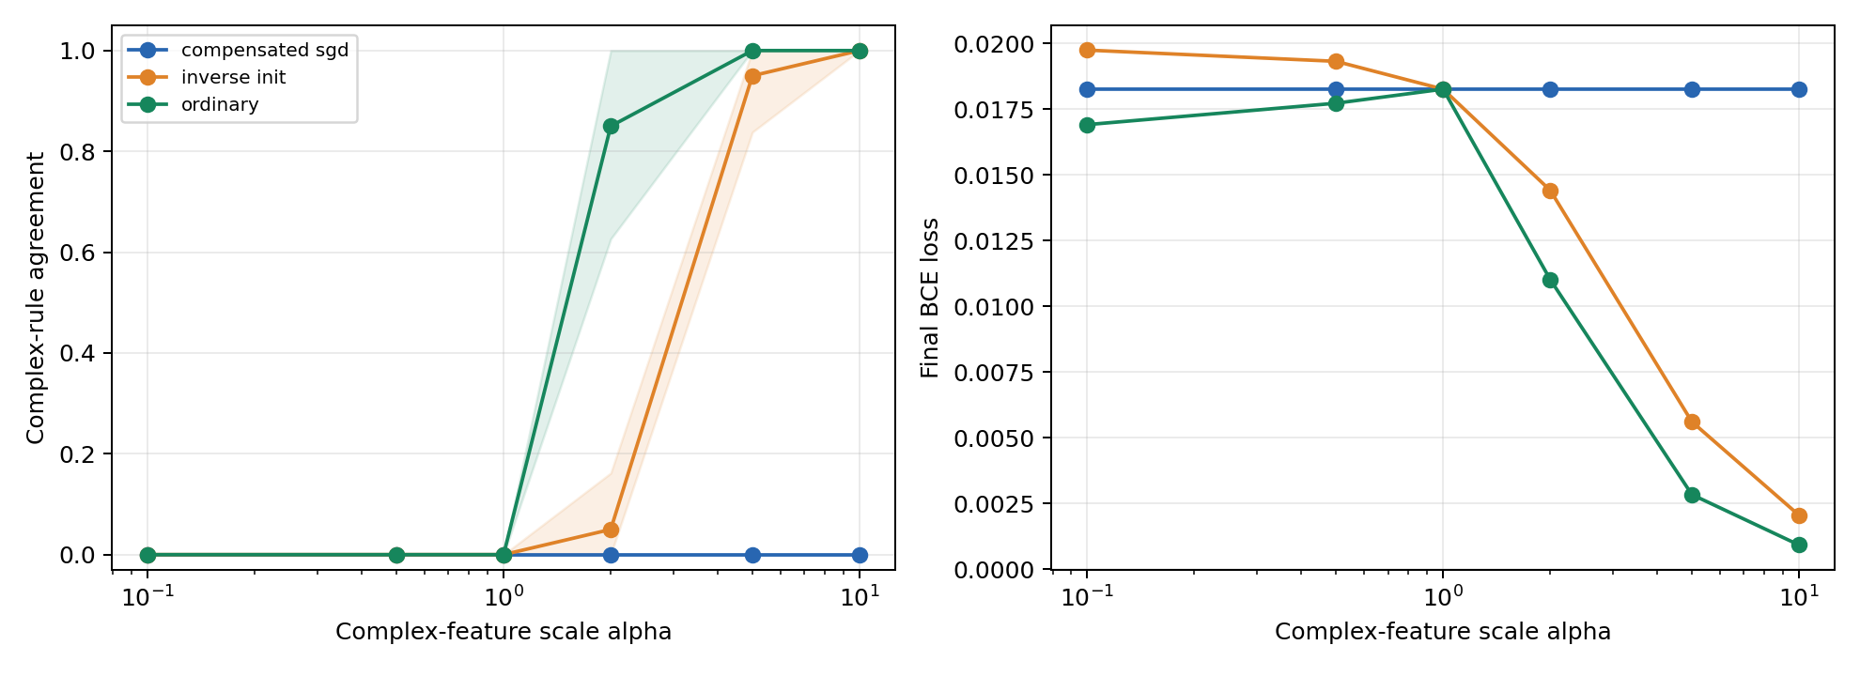
Figure 1. Final conflict agreement and training BCE versus complex feature scale. Shading shows one sample standard deviation across seeds, not a confidence interval.
Ordinary scaling reaches mean agreement 0.85 at α = 2 and 1.00 at α = 5 and 10. Inverse initialization delays the transition to 0.05 at α = 2 and 0.95 at α = 5, reaching 1.00 at α = 10. Compensated SGD remains at 0.00. At α = 5, all five ordinary runs favor the complex rule on every conflict probe; inverse initialization gives four scores of 1.00 and one of 0.75.

Counterfactual sensitivity and numerical controls
The current CSVs include the numerical counterfactual measurements. At α = 5, the means across seeds are:
Condition | Hard flip rates  simple / complex | Mean absolute probability change  simple / complex
Ordinary | 0.000 / 1.000 | 0.008 / 0.987
Inverse init | 0.050 / 0.951 | 0.167 / 0.822
Compensated | 1.000 / 0.000 | 0.911 / 0.053

Table 2. Final counterfactual sensitivity at α = 5. Hard flips compare predicted classes; probability changes compare sigmoid outputs before and after intervention.
Without compensation, larger scales increase sensitivity to the complex intervention and reduce sensitivity to the simple intervention. The compensated condition matches the unit scale reference: mean simple probability change is approximately 0.911 and mean complex probability change is 0.053 across scales.
For inverse initialization, the largest recorded initial preactivation mismatch is 2.38 × 10⁻⁷, initial logit mismatch 5.96 × 10⁻⁸, and gradient scaling mismatch 1.19 × 10⁻⁷. The maximum compensated final logit difference from the unit scale reference is 1.19 × 10⁻⁶. These values are consistent with numerical rounding.

Analysis
The shift survives matched initial functions, so changed initial predictions alone are insufficient to explain it. Compensation restores reference behavior as the reparameterization equations predict. Together, the results support an optimization based explanation within this setup. Equal training accuracy across conditions shows why that metric alone cannot identify preference.
The hard flip metrics reuse the same four contradictory prototypes as conflict agreement. With balanced prototypes and perfect original predictions, complex flip rate equals conflict agreement and simple flip rate equals its complement. Sample imbalance explains small numerical differences. These metrics are related behavioral views, not independent corroborating experiments.

Counterfactual sensitivity across feature scales
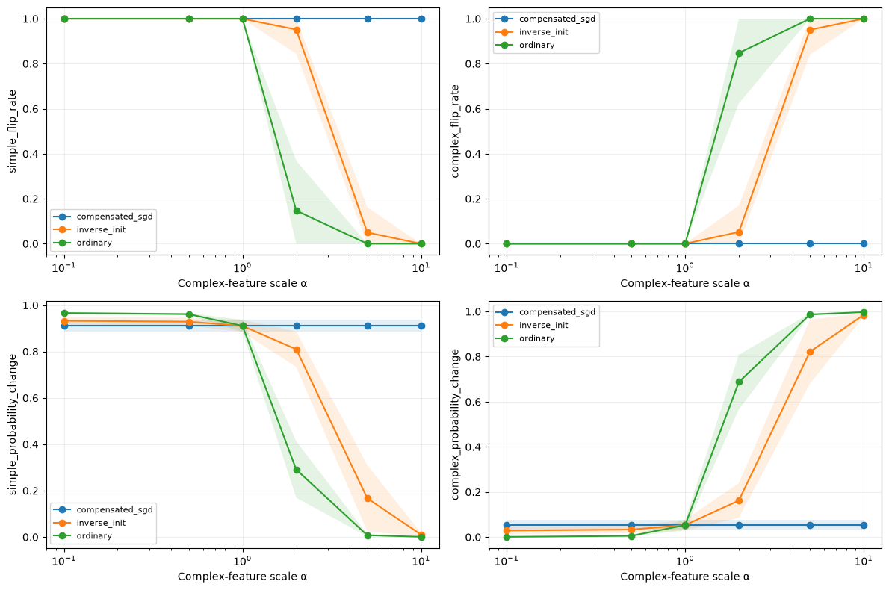
Figure 2. Final counterfactual sensitivity across complex feature scales, from Notebook 09. Top row: simple and complex hard prediction flip rates. Bottom row: mean absolute probability changes for the same interventions. Lines are means over five initialization seeds; shading is one sample standard deviation, clipped to [0, 1], not a confidence interval. The horizontal axis is logarithmic.
Read the left panels together: falling values mean predictions become less sensitive to changing the simple sign. Read the right panels together: rising values mean predictions become more sensitive to reversing the complex rule. The upper panels show changes of predicted class; the lower panels show changes of probability, including those that do not cross the classification threshold.
The ordinary condition changes most strongly between α = 1 and 2. The inverse condition makes its largest change between α = 2 and 5. The compensated condition remains nearly horizontal in every panel. The shaded bands are widest around the transitions, where initialization seeds differ most. These curves describe the tested scale values; connecting lines do not establish a precise continuous transition threshold.

Detailed interpretation of prediction results

What the conflict test establishes
The unit scale models favor the simple rule on all conflict probes after training. Under ordinary scaling, mean complex agreement rises from 0 at α = 1 to 0.85 at α = 2 and 1.00 at α = 5. Because labels, underlying samples, architecture, and update budget are unchanged, linear separability alone cannot explain preference across these runs. Numerical scale is a boundary condition for the observed simple preference in this finite training regime.
The reversal is not only an averaging effect. At α = 2, the five ordinary scores are 1.00, 1.00, 1.00, 0.75, and 0.50, so one seed is tied rather than complex dominant. At α = 5, every ordinary score is 1.00. Inverse initialization gives four scores of 1.00 and one of 0.75 at that scale; every tested seed still exceeds 0.5. Thus the complex preference survives matched initial functions in all five seeds, while its precise onset varies.
Initialization nevertheless affects the transition. At α = 2, ordinary and inverse mean agreement are 0.85 and 0.05, a paired mean difference of 0.80. Matching the initial function therefore changes the finite budget outcome at moderate scale, but does not prevent reversal at larger scales. This comparison does not uniquely attribute the difference to ReLU gates, since inverse initialization also changes initial weights and parameter norms.

Preference changes after training accuracy saturates
SGD step | Ordinary | Inverse init | Compensated SGD
0 | 0.50 | 0.50 | 0.50
25 | 1.00 | 0.45 | 0.20
100 | 1.00 | 0.80 | 0.00
250 | 1.00 | 0.85 | 0.00
500 | 1.00 | 0.95 | 0.00

Table 3. Mean complex conflict agreement during training at α = 5. Checkpoints are spaced 25 updates apart; the table selects representative checkpoints.
At initialization, all three conditions have mean agreement 0.50, although individual seed scores differ and ordinary logits are not matched. By step 25, all ordinary and inverse runs have perfect training accuracy, yet their agreement means are 1.00 and 0.45. Inverse agreement then rises to 0.80 at step 100 and 0.95 at step 500. Correct predictions on the four training prototypes therefore do not imply that behavior on conflicting inputs has stabilized.
BCE can keep changing weights after accuracy reaches 100%, because it still rewards increasing confidence. The histories show continued changes in conflict behavior during that period. We can conclude that preference evolves under continued optimization; we cannot infer an exact first learning time for each internal feature. Step 25 is the first logged checkpoint, not a measured convergence time.

What the flip test adds to the conflict test
The hard flip results describe the same behavioral reversal from another starting point. Under ordinary scaling at α = 5, simple interventions never change the class and complex interventions always do. This agrees with conflict agreement 1.00. However, both tests reuse the same four contradictory inputs, so agreement between their hard scores is not independent confirmation of two separate mechanisms.
Probability changes add information that a class decision hides. At α = 1, the complex hard flip rate is zero, but complex interventions move the class 1 probability by 0.053 on average. The model’s class decision is simple dominated on these probes without being completely insensitive to complex coordinates. Describing this as exclusive use of the simple feature would be too strong.
At α = 2 under inverse initialization, complex hard flips occur for only about 5.3% of sampled examples on average, whereas the mean absolute probability change is 0.162. Complex interventions therefore affect confidence even where they rarely reverse the predicted class. The soft metric detects responses that a threshold based metric misses; it does not measure calibration or classification quality.
At α = 5, ordinary and inverse models both have strong complex conflict preference, with means 1.00 and 0.95. Their confidence responses are less similar: the mean simple probability change is 0.008 under ordinary scaling but 0.167 under inverse initialization, while the complex changes are 0.987 and 0.822. High complex agreement can therefore coexist with residual sensitivity to the simple sign. The two conditions should not be described as having learned identical functions merely because their conflict scores are close.

What compensation and the baseline allow us to conclude
Compensated SGD preserves conflict agreement 0, simple flip rate 1, complex flip rate 0, and probability changes approximately 0.911 and 0.053 at every scale. The maximum final reference logit discrepancy is only 1.19 × 10⁻⁶. This is stronger evidence of correct cancellation than matching a coarse score alone. Since equivalence is designed mathematically, the result verifies the reparameterization control and supports the effective SGD update account; it does not independently prove that every simplicity bias phenomenon has this cause.
Both feature only baselines attain 100% accuracy in all five seeds with the matched budget. We can therefore rule out failure to learn XOR separately at the reference scale as the immediate explanation for the joint models’ simple preference. Complex only BCE remains higher, about 0.0535 versus 0.0105 for simple only. Equal final accuracy consequently does not establish equal optimization difficulty or confidence, and separate learnability does not guarantee selection in the joint model.
Together, the tests support a conditional conclusion: positive scaling can reverse diagnostic preference without changing feature information or XNOR structure; different initial predictions are not necessary; and matching effective SGD updates removes the scale dependence in this setup. The CSVs contain summary prediction metrics rather than every example’s logits, so they cannot identify individual confidence distributions. Five seeds and descriptive standard deviation bands also do not establish formal rejection of the null or generalization beyond these probes.

Experiment 2 Continuous results and conflict preference
The continuous sweep contains 90 joint runs and 1,890 recorded checkpoints, excluding five auxiliary unit scale reference runs. All joint runs finish with 100% training, validation, and held out test accuracy. The ten feature only baselines also reach 100% on all three ordinary splits with the matched budget. Separate learnability is therefore established at unit scale on unseen magnitudes as well as training inputs.
Mean feature only test BCE is approximately 0.0151 for the simple group and 0.0893 for the complex group. Equal accuracy does not mean equal confidence, optimization difficulty, or selection in a joint model. In particular, perfect held out accuracy still leaves the competing rules indistinguishable on ordinary inputs.
α | Ordinary | Inverse initialization | Compensated SGD
0.1 | 0.0000 | 0.0000 | 0.0011
0.5 | 0.0000 | 0.0000 | 0.0011
1 | 0.0011 | 0.0011 | 0.0011
2 | 0.7273 | 0.0471 | 0.0011
5 | 1.0000 | 0.9143 | 0.0011
10 | 1.0000 | 1.0000 | 0.0011
Table 4. Mean continuous complex rule conflict agreement across five initialization seeds on 2,048 fixed probes per model. Values are rounded to four decimals. The compensated mean 0.0011 matches the unit scale reference; it is not exactly zero.
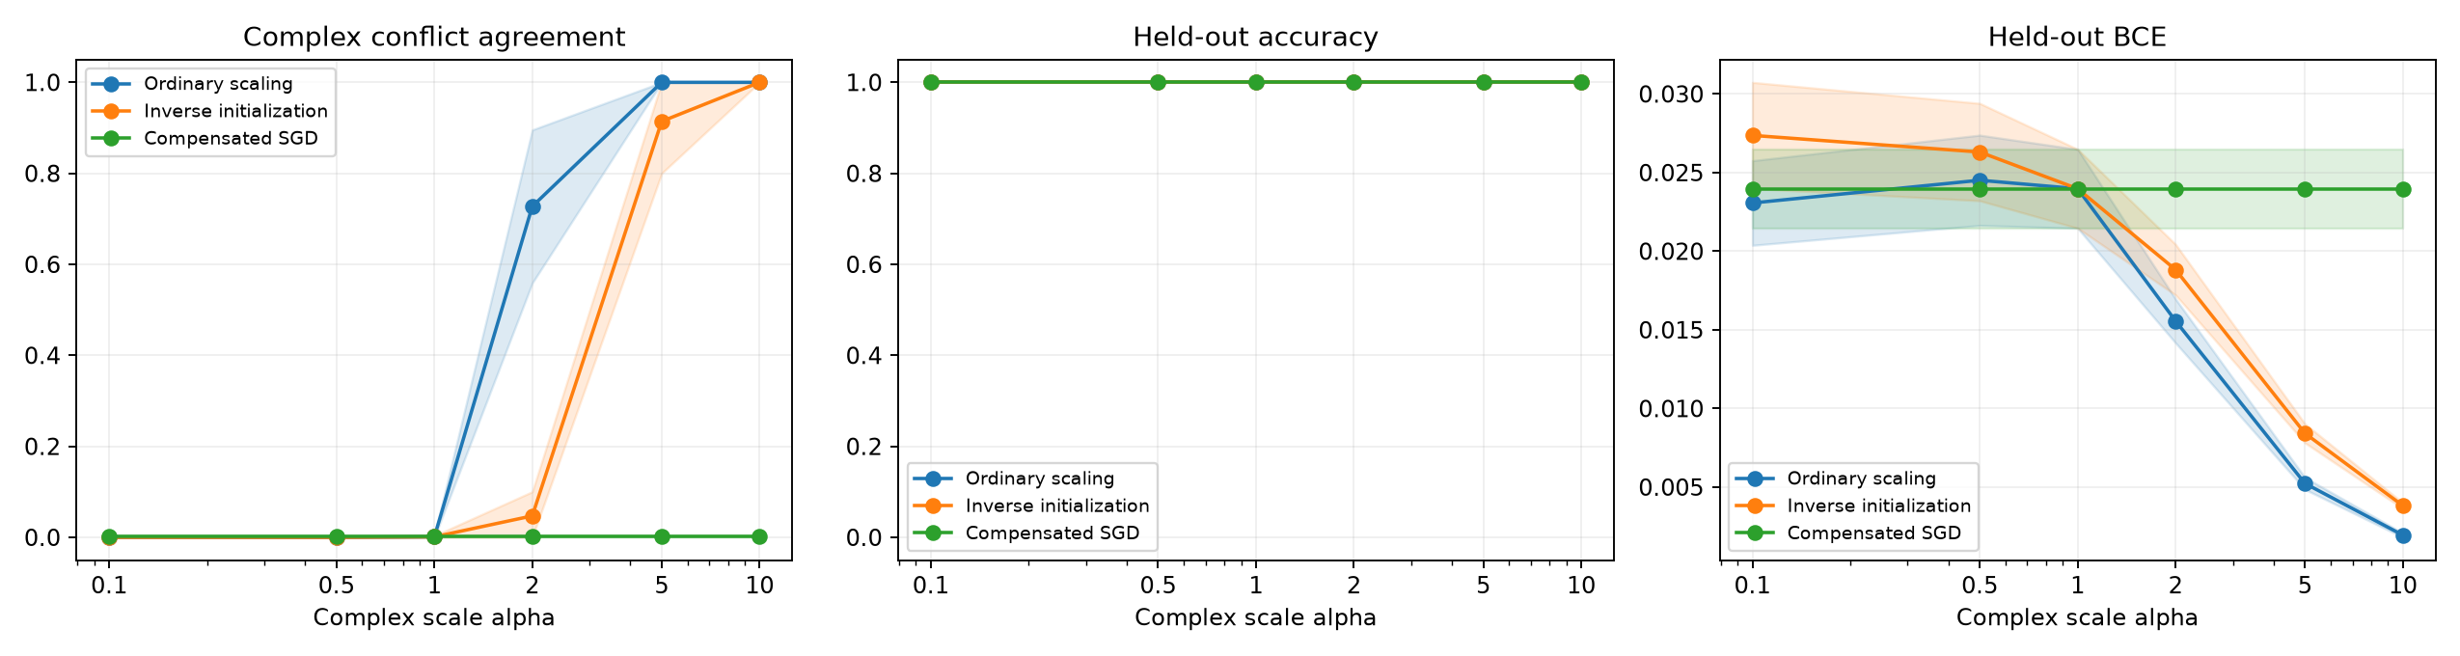
Figure 3. Continuous XNOR final conflict agreement, held out test accuracy, and test BCE across scale. Curves summarize five seeds; shading shows one sample standard deviation, not a confidence interval. All test accuracies are 1.00, despite different conflict behavior.
Ordinary scaling shifts mean agreement from 0.0011 at α = 1 to 0.7273 at α = 2 and 1.0000 at α = 5. Inverse initialization gives 0.0471 at α = 2 and 0.9143 at α = 5. Every seed favors the complex rule at α = 5 in both conditions; at α = 10 all their probes follow it. The reversal therefore survives continuous coordinates and matched initial functions.
The transition remains seed dependent. At α = 2, ordinary scores range from 0.4990 to 0.9551, with sample SD 0.1682; one seed remains just below 0.5. Inverse scores at α = 5 range from 0.7251 to 0.9893, with SD 0.1141. Six sampled scales do not determine a precise threshold.

Continuous counterfactual predictions
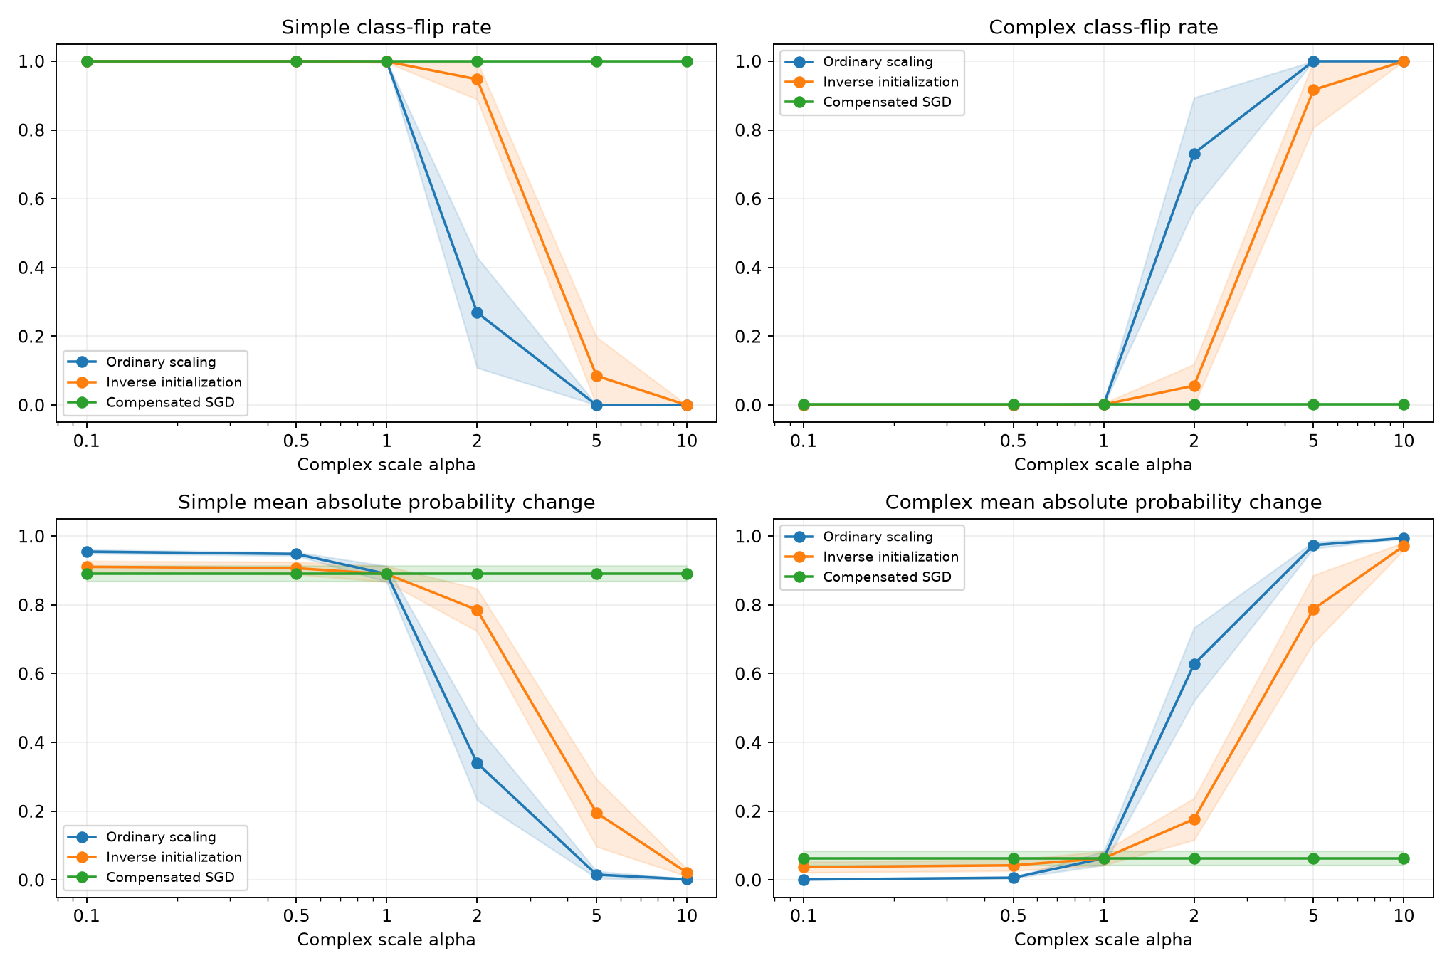
Figure 4. Final continuous test counterfactual sensitivity. Top panels show hard prediction flip rates; bottom panels show mean absolute changes in sigmoid probability. Lines average five seeds and bands show one sample standard deviation, clipped to [0, 1]. The scale axis is logarithmic.
Condition | Simple flip | Complex flip | Simple Δp | Complex Δp
Ordinary | 0.0000 | 1.0000 | 0.0157 | 0.9736
Inverse initialization | 0.0852 | 0.9164 | 0.1954 | 0.7878
Compensated SGD | 0.9988 | 0.0016 | 0.8898 | 0.0632
Table 5. Mean continuous held out counterfactual metrics at α = 5. Δp denotes the mean absolute probability change, not an accuracy change. Each per model metric averages 2,048 test examples.
At α = 5, ordinary models never change class when the simple sign is flipped and always change class when one complex sign is flipped. Yet the simple intervention still moves probability by about 0.0157. A complex dominated class decision therefore does not imply complete insensitivity to the simple coordinate.
Inverse initialized models retain greater simple sensitivity: mean simple hard flip rate is 0.0852 and probability change is 0.1954. Their complex hard flip rate is 0.9164 and probability change is 0.7878. These responses differ from ordinary scaling even though both conditions favor the complex rule on a majority of conflict probes in every seed.
At α = 2 under inverse initialization, complex interventions flip about 5.63% of test predictions but move probability by 0.1772 on average. The probability metric reveals confidence responses hidden by class decisions. For compensated SGD, every scale preserves the unit scale response: simple and complex hard flip means are 0.9988 and 0.0016, while probability changes are 0.8898 and 0.0632. Small complex responses are present even where the simple rule dominates.

Continuous training dynamics and conclusions
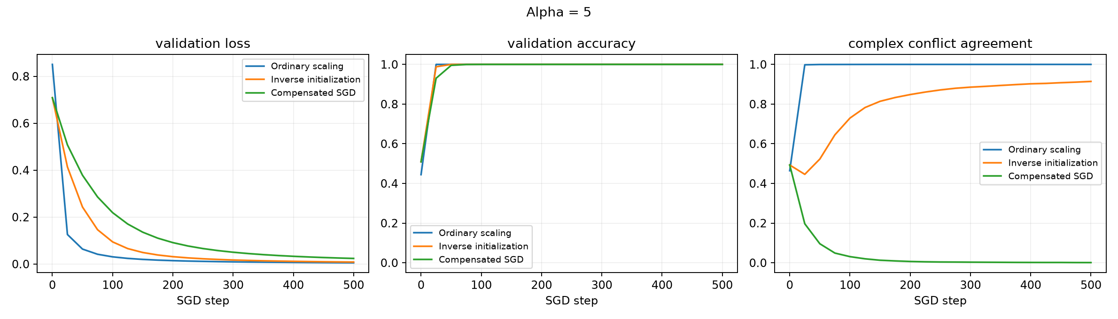
Figure 5. Continuous XNOR training at α = 5. Validation BCE, validation accuracy, and complex conflict agreement are recorded every 25 updates. Lines average five initialization seeds; this trajectory figure does not display uncertainty bands.
Update | Ordinary | Inverse initialization | Compensated SGD
0 | 0.4642 | 0.4930 | 0.4930
25 | 0.9981 | 0.4459 | 0.1966
100 | 0.9998 | 0.7295 | 0.0310
250 | 1.0000 | 0.8714 | 0.0040
500 | 1.0000 | 0.9143 | 0.0011
Table 6. Mean continuous conflict agreement at selected training checkpoints for α = 5. This trajectory is distinct from the four prototype trajectory in Table 3.
By update 100, every α = 5 run has perfect training and validation accuracy, yet inverse mean conflict agreement continues from 0.7295 at update 100 to 0.9143 at update 500. BCE still rewards confidence after the class decisions become correct, so off distribution preference can keep changing. The logged checkpoints do not identify an exact feature learning time.
Initial equivalence checks support the same mathematics on continuous inputs: maximum preactivation mismatch is 4.77 × 10⁻⁷, logit mismatch 1.19 × 10⁻⁷, and gradient scaling mismatch 2.98 × 10⁻⁸. Compensated final test logits differ from the paired unit scale reference by at most 2.62 × 10⁻⁶. Matching logits as well as coarse scores is consistent with floating point rounding and validates the implemented cancellation.
The continuous result strengthens one specific conclusion: the scaling effect is not confined to four fixed inputs. Ordinary and inverse initialized scaling reverse preference on a denser contradictory probe set while held out accuracy remains perfect. Compensation removes the scale effect under plain SGD. Experiment 3 next tests an extra simple-group coordinate; this extension alone does not isolate dimensionality, vary nonlinear complexity, or establish behavior outside the sampled magnitude range.

Experiment 3 Findings on equal supplied dimensions
The completed sweep contains 270 unique primary runs and 5,670 checkpoints. All 270 models and all 20 feature only baselines reach 100% training, validation, and test accuracy. C0 repeats the Experiment 2 design and recovers the conflict means reported in Table 4. C1 matches C0 exactly on recorded validation/conflict logits and shared effective parameters across every seed, scale, condition, and checkpoint. Its final preference and sensitivity scores also match. Adding an inactive coordinate has no observed effect, as predicted mathematically.
α | C0 and C1 ordinary | C2 ordinary | C0 and C1 inverse | C2 inverse | C2 compensated
0.1 | 0.0000 | 0.0000 | 0.0000 | 0.0011 | 0.0012
0.5 | 0.0000 | 0.0000 | 0.0000 | 0.0011 | 0.0012
1 | 0.0011 | 0.0012 | 0.0011 | 0.0012 | 0.0012
2 | 0.7273 | 0.6795 | 0.0471 | 0.0351 | 0.0012
5 | 1.0000 | 0.9993 | 0.9143 | 0.9090 | 0.0012
10 | 1.0000 | 1.0000 | 1.0000 | 0.9997 | 0.0012
Table 7. Mean final complex conflict agreement over five seeds. C0/C1 compensated agreement is 0.0011 at every scale; C2 preserves its own reference mean of 0.0012. Values are rounded, and these small means are not zero.
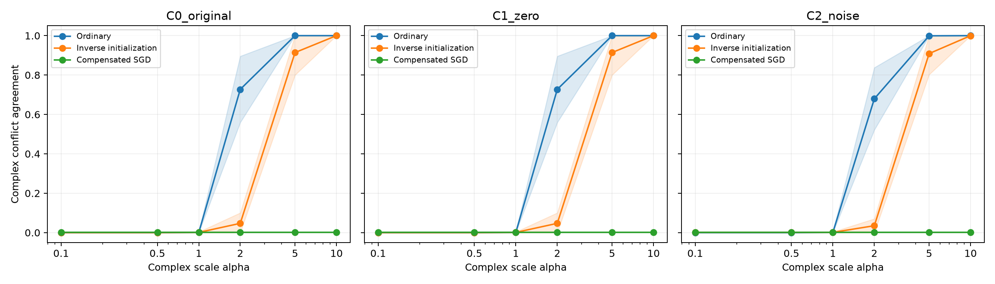
Figure 6. Experiment 3 conflict preference across scale for the original, zero-padded, and noisy inputs. Lines average five model seeds; shading is one sample standard deviation, not a confidence interval. Each model uses the same 2,048 underlying conflict probes.
Active noise changes the transition modestly. At α = 2, ordinary agreement falls from 0.7273 in C1 to 0.6795 in C2. The paired mean change is −0.0479, with sample SD 0.0305; all five seed differences are negative. Under inverse initialization, the corresponding means are 0.0471 and 0.0351, but paired differences have mixed signs. These descriptive results do not establish a formal significance claim.
At α = 5, C2 still reaches 0.9993 under ordinary scaling and 0.9090 under inverse initialization. Every seed exceeds 0.5 in both conditions. Inverse C2 scores range from 0.7358 to 0.9883; their paired mean change from C1 is −0.0053, with SD 0.0111. Noise therefore does not eliminate the reversal. At α = 10, C2 ordinary agreement is 1.0000 and inverse agreement is 0.9997, rather than exactly one for every inverse probe.

Experiment 3 Prediction sensitivity with nuisance variation
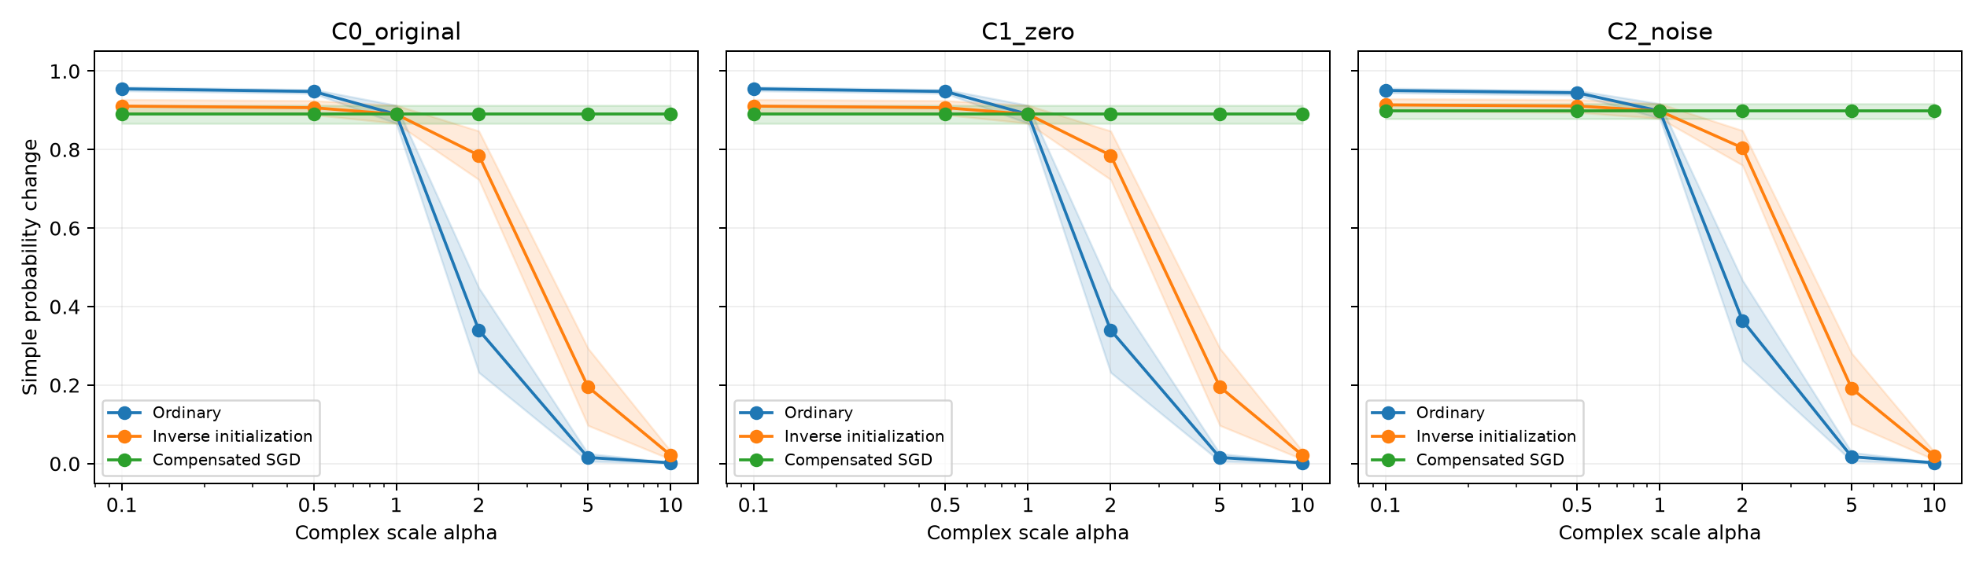
Figure 7. Mean absolute probability change after negating the simple coordinate. The nuisance coordinate and complex pair remain fixed. Panels compare C0, C1, and C2; bands show one sample standard deviation across five seeds.
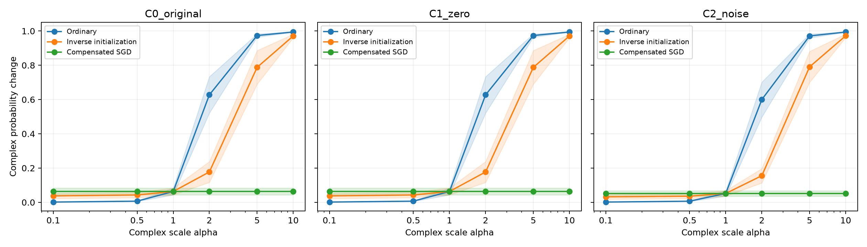
Figure 8. Mean absolute probability change after negating one complex coordinate. The simple and nuisance coordinates remain fixed. These are confidence responses, not accuracy or calibration scores; bands show one sample standard deviation.
Input and training | Simple flip | Complex flip | Simple Δp | Complex Δp
C1 Ordinary | 0.0000 | 1.0000 | 0.0157 | 0.9736
C2 Ordinary | 0.0003 | 0.9995 | 0.0175 | 0.9712
C1 Inverse | 0.0852 | 0.9164 | 0.1954 | 0.7878
C2 Inverse | 0.0858 | 0.9136 | 0.1914 | 0.7908
C1 Compensated | 0.9988 | 0.0016 | 0.8898 | 0.0632
C2 Compensated | 0.9987 | 0.0008 | 0.8981 | 0.0517
Table 8. Final test counterfactual means at α = 5. C0 equals C1. Each metric averages 2,048 test inputs per model, then five seeds. Δp is mean absolute sigmoid probability change.
The prediction responses remain close with noise. At α = 5, ordinary C2 predictions almost always flip under the complex intervention, while inverse C2 retains residual simple sensitivity. Its mean simple probability change is 0.1914 despite complex conflict agreement 0.9090. A dominant complex class decision does not imply exclusive complex dependence.
Compensation preserves different reference functions: simple/complex probability changes are 0.8898/0.0632 for C1 and 0.8981/0.0517 for C2. C2 need not match C1. Feature only test BCE increases from 0.0151 to 0.0186 when simple-group noise is added, while all accuracies stay perfect; the shared complex baseline has BCE 0.0893. This is a confidence and optimization difference, not evidence of worse classification.

Experiment 3 Training controls and interpretation
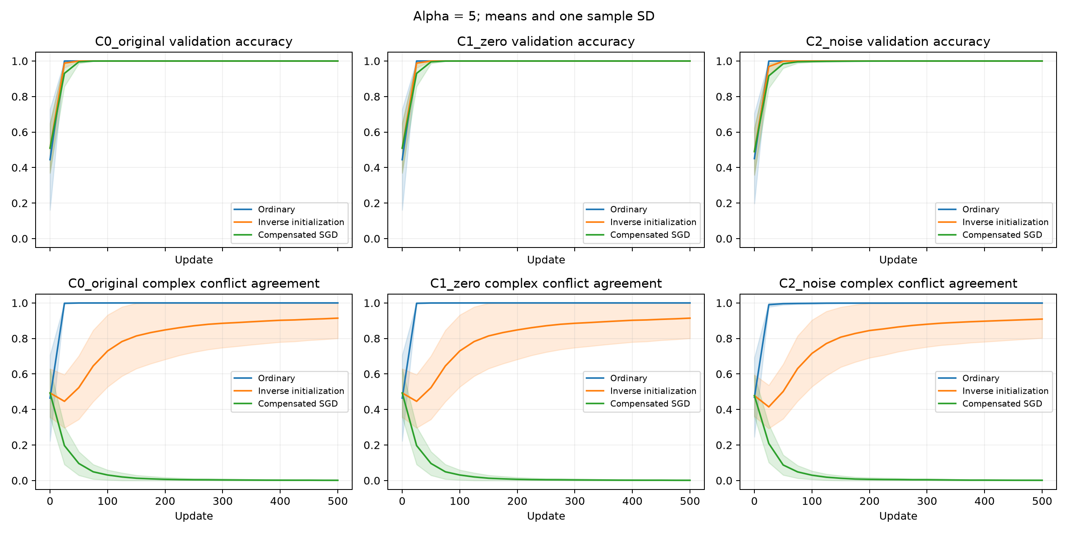
Figure 9. Experiment 3 trajectories at α = 5. The top row shows validation accuracy and the bottom row complex conflict agreement. Lines average five model seeds; bands show one sample standard deviation. Measurements are recorded every 25 updates.
Numerical comparison | Maximum logit error | Maximum parameter error
C1 versus C0 | 0 | 0
C0 or C1 compensated versus own reference | 3.10 × 10⁻⁶ | 1.55 × 10⁻⁶
C2 compensated versus own reference | 5.96 × 10⁻⁶ | 1.79 × 10⁻⁶
Table 9. Largest recorded trajectory discrepancies across scales, seeds, and checkpoints. Logits cover validation and conflict inputs. Parameters are effective weights; the C0/C1 comparison excludes the inactive nuisance column. All are within the specified 10⁻⁴ trajectory tolerance.
Initial matching also passes: maximum preactivation error is 4.77 × 10⁻⁷, initial logit error 1.79 × 10⁻⁷, and gradient scaling error 2.98 × 10⁻⁸. The compensated identities therefore survive the added coordinate. Since equivalence is designed algebraically, these checks validate implementation under plain SGD rather than independently proving a universal cause of simplicity bias.
For noisy inverse models at α = 5, every run has perfect training and validation accuracy by the logged update 100, but mean conflict agreement continues from 0.7157 to 0.9090 by update 500. In C1 the corresponding values are 0.7295 and 0.9143. The noisy compensated models are not all perfectly accurate at update 100; they are by update 250. Continued confidence optimization can change probe behavior after ordinary accuracy saturates.
Experiment 3 addresses the unequal number of supplied coordinates and shows robustness to this specific irrelevant input variation. Zero padding alone is not a dimensionality discovery because it cannot affect plain SGD. The active-noise comparison is the substantive extension: it modestly alters the transition without removing the reversal or reducing final IID accuracy. Informative dimensionality, different nonlinear rules, alternative noise strengths, and dataset-draw uncertainty remain unresolved.

9 Limitations
- Experiment 1 contains only four input prototypes. Experiment 2 removes this finite prototype restriction and evaluates unseen magnitudes, but retains the same sign rule and bounded sampling distribution. It does not establish generalization to new rules, near zero coordinates, or realistic data.
- Experiment 3 equalizes supplied coordinate counts and adds active nuisance variation, but the simple rule still needs one informative coordinate while XNOR needs two. It therefore does not equalize informative dimensionality. Results are conditional on the chosen noise distribution and matched initialization.
- Conflict and counterfactual inputs violate the training agreement constraint. Their responses do not uniquely establish internal representations or causal reliance on ordinary data.
- Ordinary splits are random samples and need not be exactly balanced; conflict sign combinations are balanced. Counterfactual and conflict metrics use different magnitudes. All three experiments fix one dataset draw per split across model seeds. Experiment 3 reuses the continuous predictive samples, so it is an extension on shared data rather than an independent dataset replication.
- Five initialization seeds and six scales provide a limited pilot. No formal hypothesis test or confidence interval is reported, and the results cannot be described as preregistered.
- The matched budget feature only baseline succeeds at α = 1. This establishes separate learnability at the reference scale, not equal convergence speed or success at every scale.
- A width 32 ReLU network and plain full batch SGD do not establish behavior across optimizers, widths, regularization choices, or training durations.
- Compensated equivalence is designed algebraically. It is a strong implementation check under its assumptions, not independent proof of a universal mechanism.

Future experiments
Experiment 3 completes the proposed comparison with an extra simple-group coordinate. Next, compare multiple nonlinear rules in a separate experiment while fixing the feature construction. Other priorities are new dataset draws, a denser scale grid near transitions, matched longer training budgets, and sensitivity to nuisance variance and initialization. Vary widths and optimizers with explicit compensation assumptions. Freeze analysis criteria before new confirmatory runs.

10 Conclusion
Across three experiments, positive input scaling can reverse diagnostic preference in a width 32 ReLU network trained with plain SGD. The effect survives continuous coordinates and an active irrelevant simple-group coordinate. In Experiment 3, all 270 primary runs and 20 feature only baselines reach 100% held out accuracy. With noise at α = 5, mean complex conflict agreement is 0.9993 under ordinary scaling and 0.9090 under inverse initialization; every seed exceeds 0.5. Reversal therefore survives matched initial functions and equal supplied coordinate counts.
Zero padding exactly reproduces the original recorded trajectories, while active noise modestly changes preference near the transition and changes confidence without reducing final accuracy. Compensated SGD preserves each input condition’s own unit scale behavior, including its small residual complex responses. This supports the effective SGD update account under the tested assumptions. The results concern contradictory diagnostic inputs; they do not equalize informative dimensionality, uniquely identify internal representations, or establish universal behavior across rules, architectures, and optimizers.

References
[1] Shah, H., Tamuly, K., Raghunathan, A., Jain, P., and Netrapalli, P. (2020). The Pitfalls of Simplicity Bias in Neural Networks. Advances in Neural Information Processing Systems, 33.
https://papers.nips.cc/paper/2020/hash/6cfe0e6127fa25df2a0ef2ae1067d915-Abstract.html
[2] Morwani, D., Batra, J., Jain, P., and Netrapalli, P. (2023). Simplicity Bias in 1-Hidden Layer Neural Networks. Advances in Neural Information Processing Systems, 36.
https://papers.neurips.cc/paper_files/paper/2023/hash/196c4e02b7464c554f0f5646af5d502e-Abstract-Conference.html
[3] Rahaman, N., Baratin, A., Arpit, D., Draxler, F., Lin, M., Hamprecht, F., Bengio, Y., and Courville, A. (2019). On the Spectral Bias of Neural Networks. Proceedings of the 36th International Conference on Machine Learning, PMLR 97, 5301–5310.
https://proceedings.mlr.press/v97/rahaman19a.html

Reproducibility
The primary sweep is implemented in run_all_experiments.py and src/experiment.py. Notebook 02 implements the matched budget capability checks; Notebooks 03–06 explain the scaling conditions and standardization check; Notebooks 08–09 read and visualize the saved metrics. These files implement Experiment 1. Experiment 2 is independent in continuous_xnor, with Notebooks 00–03 for data checks, feature only baselines, scaling controls, and result analysis; notebook_experiment.py contains their shared functions.
Numerical sources are results/final_summary.csv, results/all_runs.csv, results/02_feature_only_summary.csv, and results/02_feature_only_history.csv. Figure 1 plots the primary sweep; Figure 2 is the saved Notebook 09 counterfactual plot. Numeric tables and prediction interpretations use the saved study outputs. Seeds, data size, scale values, learning rate, and step budget are specified in Section 5. Experiment 2 uses continuous_xnor/results/final_summary.csv, training_history.csv, baseline_summary.csv, baseline_history.csv, metadata.json, and the saved split CSVs. Figures 3–5 retain the completed continuous experiment figures; all new tables and numeric interpretations are computed from those CSVs.
Experiment 3 is implemented independently in experiment_3/experiment.py and Notebooks 00–03. Its numeric sources are experiment_3/results/summary.csv, all_runs.csv, feature_only.csv, feature_only_history.csv, trajectory_checks.csv, metadata.json, baseline_settings.json, and the saved split CSVs. Figures 6–9 are the saved Experiment 3 plots. Tables 7–9 and the paired interpretations are calculated from these CSVs. C0 reuses the Experiment 2 predictive samples and reference initialization; its repeated runs are not independent new evidence.
The recorded notebook environment reports PyTorch 2.14.1+cpu. The current requirements file lists unpinned dependencies. Exact package versions and a code revision identifier should accompany any archived reproduction; the existing artifacts do not establish a fully locked environment.

